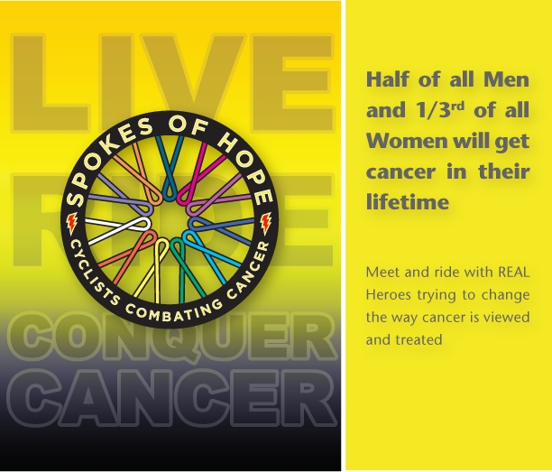  Spokes of Hope  Cancer is not contagious  But HOPE can be  Spread the Hope!  www.Spokesofhope.org | Spokes of Hope  Cancer is not contagious  But HOPE can be  Spread the Hope!  www.Spokesofhope.org
Spokes of Hope  Cancer is not contagious  But HOPE can be  Spread the Hope!  www.Spokesofhope.org | Spokes of Hope  Cancer is not contagious  But HOPE can be  Spread the Hope!  www.Spokesofhope.org
Spokes of Hope  Cancer is not contagious  But HOPE can be  Spread the Hope!  www.Spokesofhope.org | Spokes of Hope  Cancer is not contagious  But HOPE can be  Spread the Hope!  www.Spokesofhope.org
Spokes of Hope  Cancer is not contagious  But HOPE can be  Spread the Hope!  www.Spokesofhope.org | Spokes of Hope  Cancer is not contagious  But HOPE can be  Spread the Hope!  www.Spokesofhope.org
Spokes of Hope  Cancer is not contagious  But HOPE can be  Spread the Hope!  www.Spokesofhope.org | Spokes of Hope  Cancer is not contagious  But HOPE can be  Spread the Hope!  www.Spokesofhope.org

